ASSIGNMENT4

|  |  |
| --- | --- |
| Date | 15 October 2022 |
| Team ID | PNT2022TMID14925 |
| Project Name | Signs with smart connectivity for better road safety |

**Ultrasonic sensor simulation in Wokwi**

**Question:**

Writeacodeandconnectionsinwokwifortheultrasonicsensor.Wheneverthedistanceislessthan100cmssend an“Alert” to IBM cloudanddisplayinthedevicerecentevents.

# Code:

#include <WiFi.h>#include<PubSubClient.h>

voidcallback(char*subscribetopic,byte*payload,unsignedintpayloadLength);

//-------credentialsofIBMAccounts------

#defineORG" ids9ks2v

"//IBMORGANITIONID

#defineDEVICE_TYPE"MyDeviceType"//DevicetypementionedinibmwatsonIOTPlatform#define DEVICE_ID "12345"//Device ID mentioned in ibmwatson IOT Platform

#defineTOKEN"12345"//Token

Stringdata3;

charserver[]=ORG".messaging.internetofthings.ibmcloud.com";charpublishTopic[]="iot-2/evt/Data/fmt/json";

charsubscribetopic[]="iot-2/cmd/test/fmt/String";charauthMethod[]="use-token-auth";

chartoken[]=TOKEN;

charclientId[]="d:"ORG":"DEVICE_TYPE":"DEVICE_ID;

WiFiClientwifiClient;

PubSubClientclient(server,1883,callback,wifiClient);constint trigPin =5;

const int echoPin = 18;#defineSOUND_SPEED0.034longduration;

floatdistance;voidsetup(){

**Serial**.begin(115200);pinMode(trigPin,OUTPUT);pinMode(echoPin, INPUT);wificonnect();mqttconnect();

}

voidloop()

{

digitalWrite(trigPin, LOW);delayMicroseconds(2);digitalWrite(trigPin, HIGH);delayMicroseconds(10);digitalWrite(trigPin,LOW);duration = pulseIn(echoPin, HIGH);distance=duration*SOUND_SPEED/2;**Serial**.print("Distance (cm): ");**Serial**.println(distance);if(distance<100)

{

**Serial**.println("ALERT!!");delay(1000);

PublishData(distance);delay(1000);

if(!client.loop()){mqttconnect();

}

}

delay(1000);

}

voidPublishData(floatdist){mqttconnect();

Stringpayload="{\"Distance\":";payload+=dist;

payload+=",\"ALERT!!\":""\"Distancelessthan100cms\"";payload+= "}";

**Serial**.print("Sendingpayload:");

**Serial**.println(payload);

if(client.publish(publishTopic,(char*)payload.c_str())){

**Serial**.println("Publishok");

}else{

**Serial**.println("Publishfailed");

}

}

voidmqttconnect(){

if (!client.connected()) {**Serial**.print("Reconnectingclientto");**Serial**.println(server);

while(!!!client.connect(clientId,authMethod,token)){

**Serial**.print(".");delay(500);

}

initManagedDevice();

**Serial**.println();

}

}

voidwificonnect()

{

**Serial**.println(); **Serial**.print("Connecting to ");WiFi.begin("Wokwi-GUEST", "", 6); while (WiFi.status() !=WL_CONNECTED){delay(500);

**Serial**.print(".");

}

**Serial**.println(""); **Serial**.println("WiFiconnected"); **Serial**.println("IP address: ");**Serial**.println(WiFi.localIP());

}

voidinitManagedDevice(){

if (client.subscribe(subscribetopic)) {**Serial**.println((subscribetopic)); **Serial**.println("subscribe tocmdOK");

}else{

**Serial**.println("subscribetocmdFAILED");

}

}

voidcallback(char*subscribetopic,byte*payload,unsignedintpayloadLength)

{

**Serial**.print("callbackinvokedfortopic:");

**Serial**.println(subscribetopic);

for(inti=0;i<payloadLength;i++){

//Serial.print((char)payload[i]);data3+=(char)payload[i];

}

**Serial**.println("data:"+data3);data3="";

}

# Diagram.json:

{

"version":1,

"author": "sweetysharon","editor": "wokwi","parts":[

{"type":"wokwi-esp32-devkit-v1","id":"esp","top":-4.67,"left":-114.67,"attrs":{}},

{"type":"wokwi-hc-sr04","id":"ultrasonic1","top":15.96,"left":89.17,"attrs":{}}

],

"connections":[

["esp:TX0","$serialMonitor:RX","",[]],

["esp:RX0","$serialMonitor:TX","",[]],[

"esp:VIN","ultrasonic1:VCC","red",

["h-37.16","v-178.79","h200","v173.33","h100.67"]

],

["esp:GND.1","ultrasonic1:GND","black",["h39.87","v44.04","h170"]],

["esp:D5","ultrasonic1:TRIG","green",["h54.54","v85.07","h130.67"]],

["esp:D18","ultrasonic1:ECHO","green",["h77.87","v80.01","h110"]]

]

}

# CircuitDiagram:

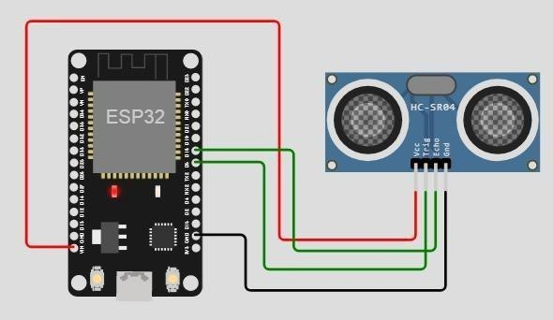

**Output:**

Wokwioutput:

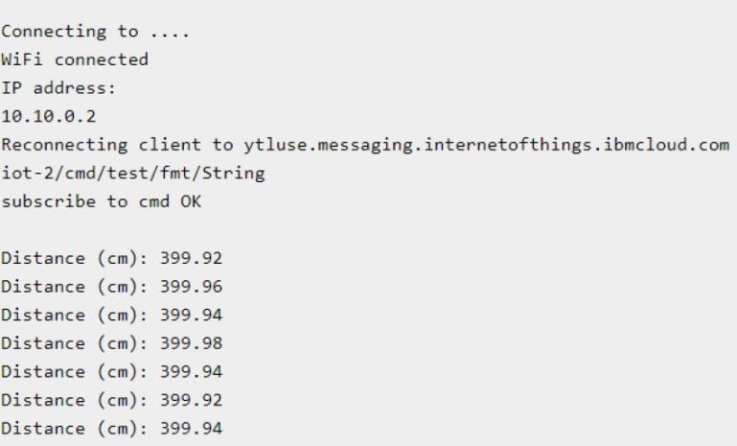

# IBMcloudoutput:

